# CS 255 System Design Document Template

## UML Diagrams

### UML Use Case Diagram

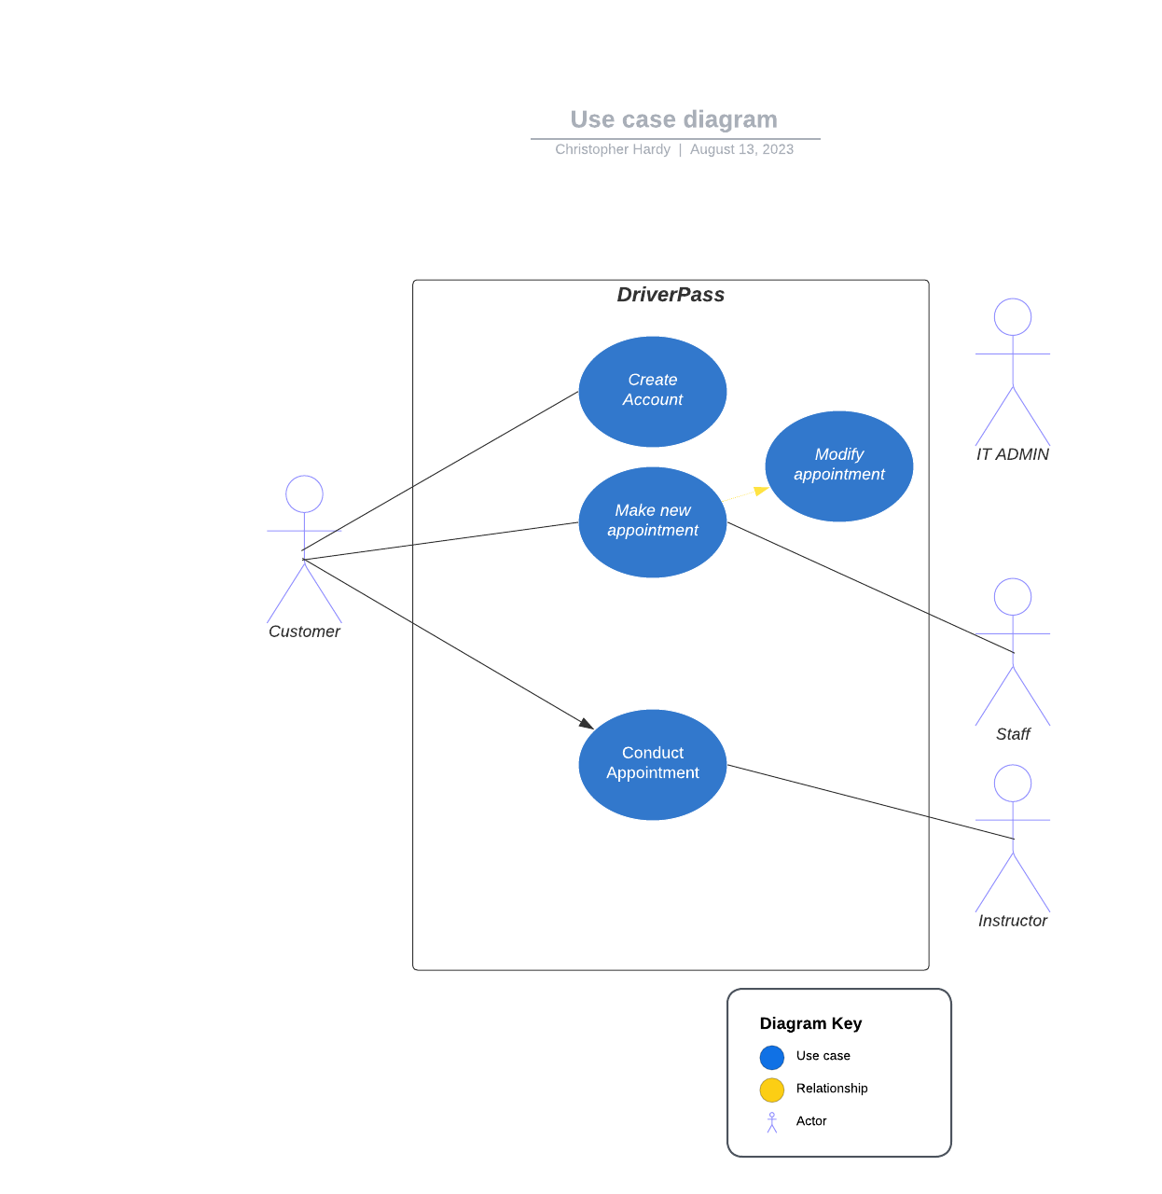

### UML Activity Diagrams

### UML Sequence Diagram

### UML Class Diagram

## Technical Requirements

The DriverPass system will be primarily managed by a cloud host. This will house the web servers and databases used for user information, appointments, and business documents. The office computers will use Windows. The office portion of the computers can have standalone windows whereas any learning computers will use Windows Server/Client applications. The IT Administrator will have access to these systems to perform updates for security and reliability.